HaSS SA Conference 2021
May 1st 2021 Presenters: Raelene White, Deana Cuconits & Sandra Siladji
Guest Speaker Anthea Perkas presenting ways to implement authentic design and architecture within your school community using the HaSS (particularly Economics and Business) framework.
Please visit the website(s) below. You can access ‘Economics and Business a Support Page for SA Teachers’ (Economics and Business) for today’s workshop but you are welcome to visit other work including ‘Geo Literacy’ (Geography) and ‘What is Justice’ (Civics and Citizenship) for ideas to use in your classroom.
It is our hope that the pages will provide extensive guidance when designing learning in collaboration with students in year 5 – 7.
http://economicsandbusiness.weebly.com/
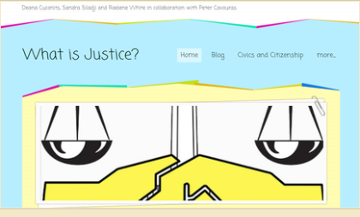
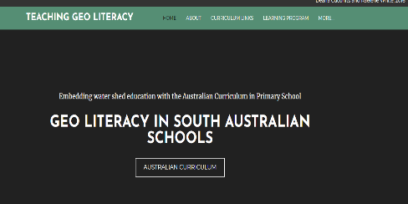
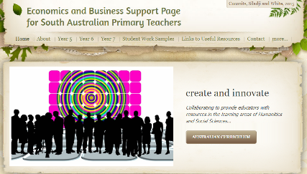

The Economics and Business content in Year 5, 6 and 7 involves two strands:
- Economics and Business Knowledge and Understanding
- Economics and Business Skills
Our thinking when planning and creating the Economics and Business website began from the flowchart below; starting with the individual as a consumer, then to developing understandings around the implications of decision making and by year 7 encouraging students to think using an entrepreneurial mindset.
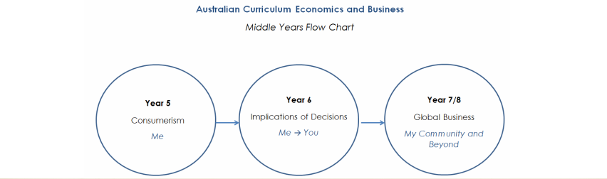

Economics and Business education is about developing informed global citizens embedded with critical thinking skills and future mind sets.

