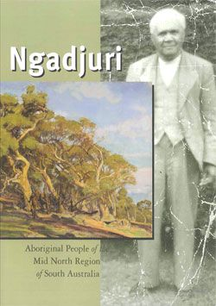
NGADJURI: Aboriginal people of the Mid North Region of South Australia

WAITING LIST FORM

HaSS SA (Humanities and Social Sciences Educator Assocation)

ABN 68 681 600 551

PO Box 54
Prospect Hill SA 5201
Email sasose@activ8.net.au
Website www.hass-sa.asn.au

Please note that the Ngadjuri book is currently out of print as of September 2024. If you wish to go on a waiting list, please complete this form

Name (individual or organisation)
_____________________________________________________

Email _________________________________________________

Postal address _________________________________________

______________________________________________________Postcode______________

Please keep my details above on the waiting list for _____ copy/copies of the book Ngadjuri: Aboriginal people of the Mid North Region of South Australia when it becomes available in the future.

We thank you for your interest.

In the meantime, you may be able to borrow a copy from a local library, purchase a second hand copy by searching online. Many schools have copies so if you in a school you may be able to arrange to borrow from a nearby school.
Please post completed form to the address above or email a copy to sasose@activ8.net.au

Form updated 14 September 2024

