Aboriginal Dreaming stories, birds and the local environment

A strategy for early and primary years R-5

Trefor Barnes

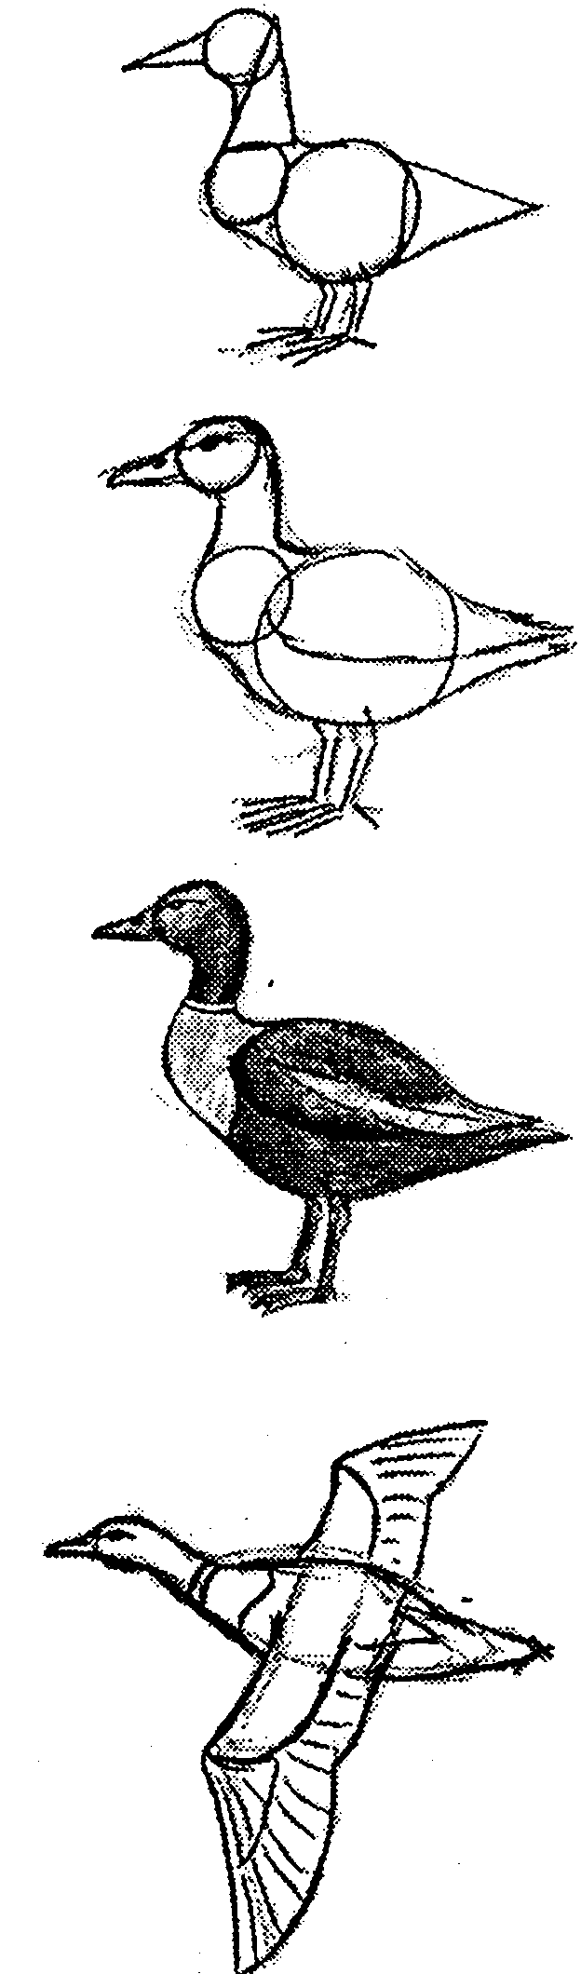

Dreaming stories, birds and the local environment

This unit has a focus on birds and Aboriginal Dreaming and was developed by Trefor Barnes. It incorporates learning based on the R-3 Aboriginal studies units Thukeri, the bony bream, Mar the cockatoo, Winda, the owl, Urrakurli, Wakarla and Wildu and other Dreaming stories which have relevance to the school's local environment. The books Ngarrindjeri Dreaming stories and Ngarrindjeri people and environment: past, present and future (available in many schools) are relevant, as Ngarrindjeri country is adjacent to the Mt. Lofty Ranges. Learning from this unit can be adapted for other environments and can enable students to achieve outcomes in science, arts and English, as well as humanities and social sciences. 'Learning with children in my class is ongoing as I prefer to use elements of Aboriginal knowledge every day and not as a particular study. This reflects my approach and does not imply criticism of other approaches.' Trefor Barnes

Before you start
Have available recommended Dreaming stories and background information from and about local Aboriginal people and their cultures and about indigenous flora and fauna. Choose resources that include Aboriginal communities, Dreaming stories, environments, birds, animals and plants which are locally relevant or the next best available. Some are published in forms not suitable for young children, but the teacher can adapt.

Organise large but simple maps to show children links between stories and country. Maps should show the local Aboriginal group's country and adjoining lands, as well as links with South Australia and Australia. This helps show children how Dreaming stories map/tell/sing the land and how Aboriginal people do not live in isolation from neighbouring groups. Each story told can be indicated on the map using small cardboard indicators and adhesive.

Arrange with teacher/librarian to access nature pictures, Internet sites, videos and books which give valued information about environmental features and creatures relevant to stories learned.

Display posters or photographs showing local Aboriginal people, past and present, as well as birds, fish, reptiles, bush foods and plants which are Indigenous to the local area. It would also be useful to have pictures of non-indigenous birds displayed separately so that students learn differences.

Student learning outcomes
Through the activities in this unit, students can easily achieve outcomes in humanities and social sciences, science and technology, as well as building explicit skills in contextual literacy and numeracy. For example, when making puppets or a sand pit landscape, students can estimate, count and measure.

Initial lessons with students
Teach one or more of the Aboriginal studies units following the advice given in the booklets Thukeri; Winda; Mar; Urrakurli, Wakarla and Wildu. These materials have been published for some time but are still relevant. Songs for Aboriginal Studies and Reconciliation CD and songbook by Buck McKenzie, contains songs for these three stories as well as teaching ideas – see www.hass-sa.asn.an/resources

If students ask 'Is this story true?', explain that Dreaming stories are to educate. Ask what they have learnt from the story and if that is true. The unusual aspects of stories make them memorable. Oral stories use the environment as illustrations, just as a book uses pictures. The stories teach about features of local environments, provide observations of behaviour and the appearance of animals, about 'rules for living' and how spirit ancestors live on in particular environments, though not all stories teach all aspects.

Each time a story is introduced, mark the area on maps to show how stories 'tell the land'. Preliminary work needs to be done on the concept of maps. A sand pit can be used to create hills, creeks and roads to show children a scale version. Map the school area indicating, for example, the area which the class is responsible for cleaning as well as other areas. Make papier-mâché, fabric or foam-rubber animal or bird puppets or costumes.

Aboriginal guests
Organise for a visit by one or more Aboriginal guests, who may be local community representatives or others, who have the confidence to share aspects of Aboriginal culture with students. The visits should occur preferably after students have completed some learning, so that they can share and celebrate what they have learned so far and will know enough to ask relevant questions of a guest in order to learn more. Ensure that each guest understands what children already know or do not know. Always meet your guests and don't assume they will feel comfortable in the school environment.

Help children differentiate between indigenous birds and introduced species and ways in which indigenous species can be protected for future generations.

Record skills and knowledge outcomes met by children, such as research, listening, writing, observation, manipulation, visual art, drama, dance.

Observation and song making Go for a nature walk near scrub, in school grounds if possible. Ask children 'What do you think this is?', 'What sound is that?', 'Could we eat this?' In other words, find out what they know. Sit quietly and try to identify bird sounds and birds in general. Encourage them to use all their senses to learn as much as possible so that afterwards they can practise movements, draw and paint what they have observed. Tell children some Ngarrindjeri or other Aboriginal names for birds and plants and ask them to describe their different habits and habitats. Children could make up a song about a bird's appearance and behaviour, perform the song at assembly and/or make a class 'big book' about a bird which has been observed.

Children get a feel for the environment through the senses of touch, sight, sound and smell. The sense of taste can be approximated by careful monitoring of what bush foods can be sampled, such as native cherries. Record the observations with photographs then compare these later so that children become is aware of seasonal changes.

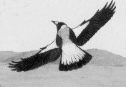 | Magpies, crows and eagles Many school yards will have magpies which visit occasionally. A Ngarrindjeri fishing story, 'Neilung', tells why Multhari, the magpie, likes to perch up high and sometimes walks quickly at other birds, as though angry at them. The story is told in Ngarrindjeri people and environment: past, present and future. Daldauwi, the crow, has smoky eyes from where Multhari hit him in frustration with his fire stick.

The pelicans, who used to be black, were splashed with white where the scales of the fish, thrown by angry Multhari, stuck to their bodies. Male magpies have white backs, while females and juveniles are grey.  Magpies and crows are often seen in the same vicinity as an eagle and sometimes appear to tease or chase the eagle. The Adnyamathanha story of Urrakurli, Wakarla and Wildu is about magpie (Urrakurli), and the crow (Wakarla), teasing Wildu, the eagle.  In nature, they are flying at eagle to keep him away from their nests. | 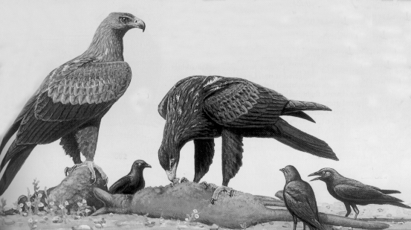

Bird sounds and names Listen to the sounds made by birds and make links, if possible, with their Aboriginal names. The crow, for example, has names which are onomatopoeic. In western Victoria it is War (pronounced as in jar), the same sound as the beginning of crow's name Wakarla in Adnyamathanha language, and Kaanka in Pitjantjatjara language.
The Kaurna name, Kurraka, for magpie and the Adnyamathanha name, Urrakurli, are a little like the magpie's song in the morning. Children could learn to 'sign' names for birds and other animals, using signs from Australian signed English or Auslan.

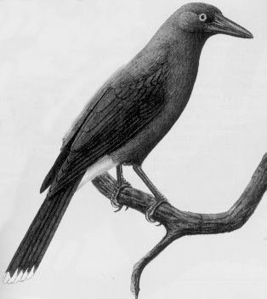 | Currawongs  The Ramindjeri people of Encounter Bay called the jaybird, now known as the currawong, who was from the Bald Hills, Wati-eri. When in human form, Wati-eri was known as a sneak and a good climber, but not as good at climbing as Lepuldalingul, the small possum.  If you watch the black-winged currawong, you will notice that they are dark grey with white on the end of their tail, very quiet, even when flying. They are omnivorous (ie they eat meat and vegetable foods), and make a bell-like call occasionally, which sounds like kiling-kildi. They are usually seen singly and in pairs. They silently search the ground and cling to the side of tree trunks to pull off bark in search of insects.

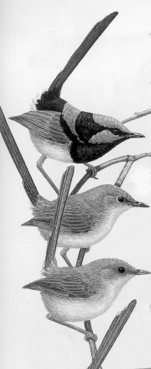 | Blue wrens Note that wrens are often referred to in bird books as fairy-wrens. The most common in South Australia is the Superb Fairy Wren, often referred to as blue wren. If there are blue wrens in the vicinity of the school, students can observe that they hide in dense bushes where they are relatively safe from cats, foxes and other predators. Their Ngarrindjeri name, Waatji Pulyeri, means 'little one of the lignum bush', a bush which commonly grows near the Murray River and Lakes. In one Ngarrindjeri story, set near Milang on Lake Alexandrina, the Waatji Pulyeri people had to live in the waatji (lignum) bush to stay away from the fish hawk, sparrow hawk and night owl men.  Waatji Pulyeri flit from ground to bush as if to say 'keep low so they can't see us'. The Ngurunderi story and Waatji Pulyeri stories in the book Ngarrindjeri Dreaming stories describe why they were made to live in reeds or bushes. Children could use small branches and twigs to make a 'home' for Waatji Pulyeri so cats, snakes and foxes can't get in. Show the created habitat at assembly. View the Ngurunderi video (if you have it in your school) to see how Ngurunderi turns the shy people into Waatji Pulyeri.  Differences between birds  The 'Waatji Pulyeri' story is about the competition the birds had, to see who could fly highest. See Jimmy Rankine, Ngarrindjeri man, telling this story at https://www.youtube.com/watch?v=Sle62XV0BO0 The story explains about the heights to which various birds regularly fly. The shag or cormorant doesn't fly high at all but dives into the water, then sits and appears to be hanging out its wings to dry. Other birds in the story are magpie, crow, mountain duck, blue crane, pelican, eagle and swan.  The wagtail is a messenger bird in many Aboriginal cultures, waving its tail and looking at people as if to attract their attention.  Birds in the Kondili story, in Ngarrindjeri people and environment: past, present and future, include the skylark, wagtail and parrots.

A story, from the Murray Valley in western New South Wales, of the sparrow hawk, is that it spreads fire, and children can understand this when they see a hawk hovering in the sky, rapidly fanning its wings. Its name, Girriki, is very similar to its Ngarrindjeri names Kirke, Kirraki and Kirr-a-kee. Comparison of names provides an opportunity to talk about similarities in Aboriginal languages along the Murray River system. | 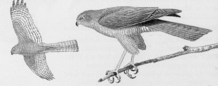

Birds' diets
Children can observe that some birds are seed eaters, some prefer insects and others eat meat, eggs, grubs or fish. Some mainly eat nectar from flowers, eg honeyeaters, wattle birds.

Birds’ habitats  The white-faced blue heron, ibis and brolga are usually found near fresh water wetland environments and this is explained by stories.  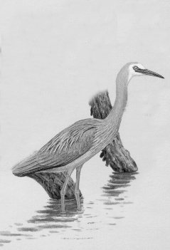 | The crested pigeon clatters its wings when taking off to fly. This is explained in 'The dove's grinding stones' story in the book Flinders Ranges Dreaming, as the noise she made when the crested pigeon stole the dove's grinding stones. The red-eyed dove has red eyes from crying at losing her grinding stones.  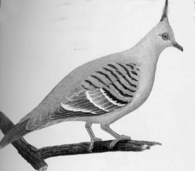  The story of 'The diver and the duck', also in the book Flinders Ranges Dreaming, explains why divers (grebes) dive to safety under the water, whereas ducks generally fly away. Both ducks and divers can often be seen in dams, lakes and wetlands.  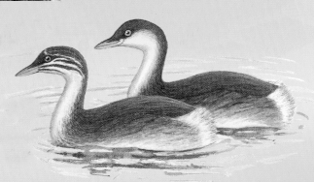

A story from the south east of South Australia tells of the creation of the wetlands there by Prolgi (brolga) after it was tricked by Pinjali (emu). Prolgi pushed her beak into the ground to make fresh-water springs, which forced Pinjali back north to mallee country, after which both birds became features of the night sky. Pinjali can be seen in winter as the dark shape in the Milky Way, the head being next to the Southern Cross and the neck passing through the Pointers. The Prolgi are the Magellanic Clouds. If students have a sleepover during terms 2 or 3, they might see emu and brolga in the sky. A similar story, based on the emu and bush turkey (bustard), is published in Flinders Ranges Dreaming.

Many of the wetlands in the south east of South Australia have been drained so there are fewer wetland birds, but several people have been and are involved in regenerating wetlands and indigenous vegetation around the state, which is encouraging indigenous fauna to return.

Drawing birds Use published photographs or drawings of birds to use as a base for children's drawings. Model a drawing by using oval, circle, triangle or other easy-to-recognise shapes as building blocks. Alternatively, use an overhead projector or grid method to make life-size drawings. For example Wanyi, the mountain duck, is mentioned in Ngarrindjeri Dreaming stories and can be drawn following the steps shown on the front page of this handout.

Summary
Children learn about birds' habitats through real observations, through use of models, as well as videos and books. Storytelling expands their appreciation and this is reinforced through observation, retelling, song, mime, plays, building craft objects, writing, publishing. Mapping helps children to learn that different Aboriginal peoples lived in different environments and that the diversity of birds, in particular, is sometimes the same and sometimes different according to the environments. They learn too that Aboriginal peoples passed on knowledge of creatures in their environments through Dreaming stories.

Caring for birds Children are now ready to 'adopt' an animal by protecting and nourishing the habitat of a particular bird. Children could individually or in a small group choose a bird to care for in a similar way -to how Aboriginal people care for their particular 'friend', 'totem'* or ngatji, as they are known by Ngarrindjeri people. Children could learn about the habitat of their chosen bird and act in ways to care for it through planting particular food or shelter bushes or trees and educating others about the bird's needs through talking, drawing, miming, writing, acting. They might team up with a 'buddy' in another year level, or work as a small group with a parent or volunteer or with the teacher/librarian. Support may be available through information from the South Australian Museum, Gould League https://gould.org.au/ , Arbury Park Outdoor School. Children could help to make sure their pet cats are inside their house at night so they can't hunt the Waatji Pulyeri, as it feeds on insects in the moonlight.

Sharing learning Children can learn from Aboriginal people about how their lives are both the same as and different from that of their ancestors. They could practise language activities with their Aboriginal guest speaker, if the guest has sufficient knowledge and confidence to do this. Refer also to pronunciation guides in Ngarrindjeri Dreaming stories and other Aboriginal studies resources.

Celebrate learning with an Aboriginal person and with parents and other classes at the school or with other schools via technology. Learn more through a sleepover at school or at campsites such as Arbury Park Outdoor School.

Use the same strategies in this unit to learn about different land and sea creatures, such as the sea creatures in the Kondili story and those in Ngarrindjeri Dreaming stories.

* a totem is a general term which describes the special link which many Aboriginal people have with an animal, fish, bird or plant. Traditionally, Aboriginal people care for their totem as they would a brother or sister or friend.

